Task 1: Create one IAM User and assign EC2 and S3 Full Access

Objective
Create an IAM user who has full administrative permissions only for Amazon EC2 and Amazon S3 services.

Prerequisites
- AWS Account
- IAM permissions to create users and attach policies

Implementation

Step 1: Login to AWS Console
AWS Console → IAM

Step 2: Create User
IAM
→ Users
→ Create User
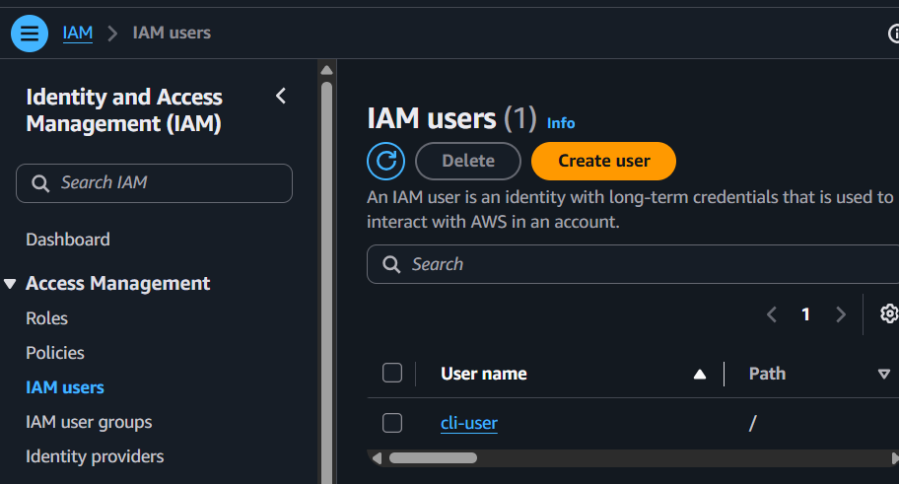
Enter
Username : DevUser
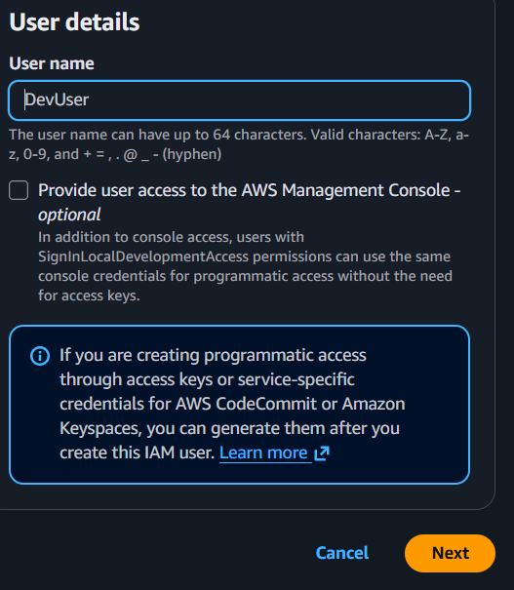
Click
Next

Step 3: Assign Permissions
Choose
Attach policies directly and select first policy “AmazonEC2FullAccess”
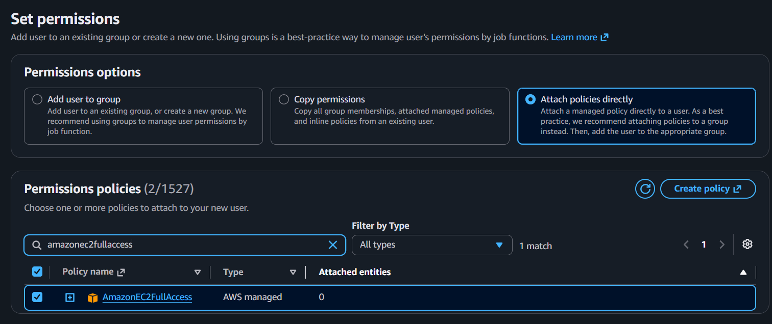
Search and select another policy “AmazonS3FullAccess”
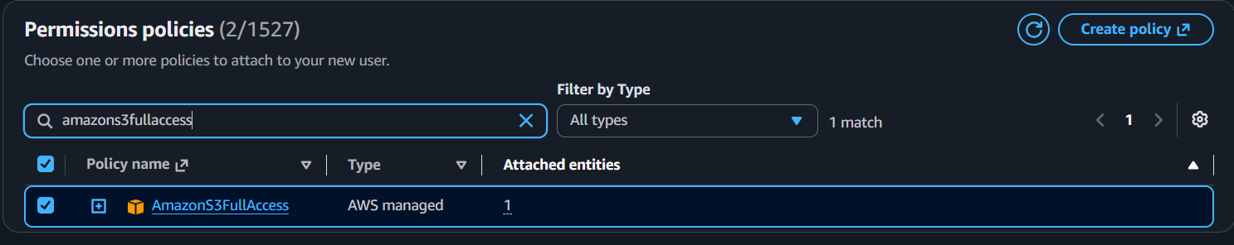
Click Next after that
Create User
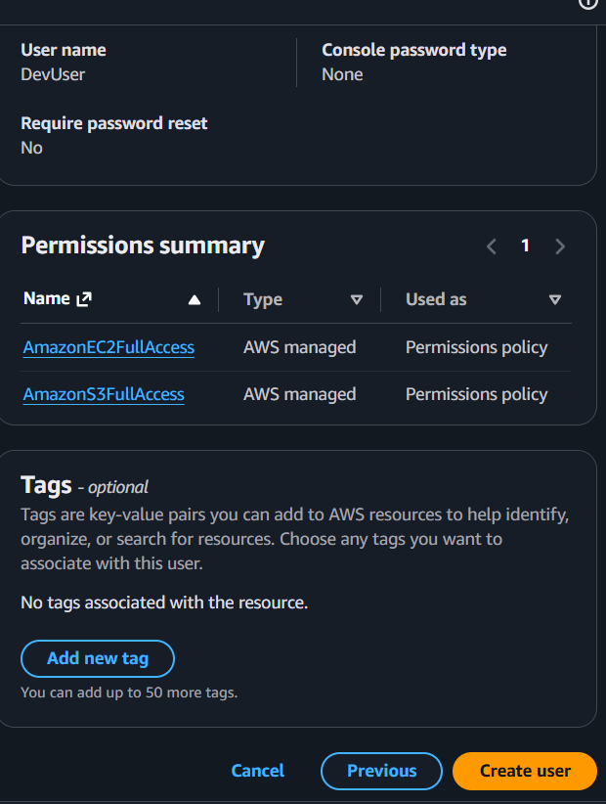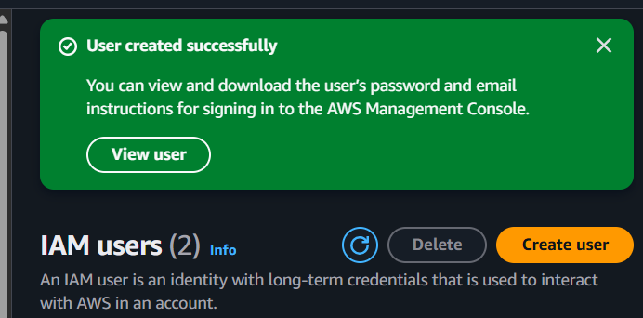

Step 4: Create Console Password
Open the user
Security Credentials
→ Console Access
→ Enable Console Access
Assign a password.
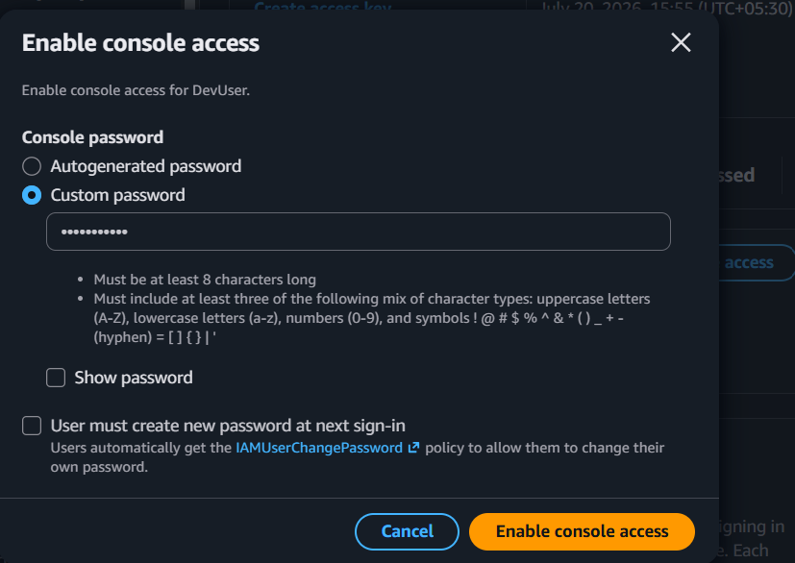

Validation

Validation 1
Open
IAM
→ Users
→ DevUser
→ Permissions
Verify attached policies
AmazonEC2FullAccess
AmazonS3FullAccess
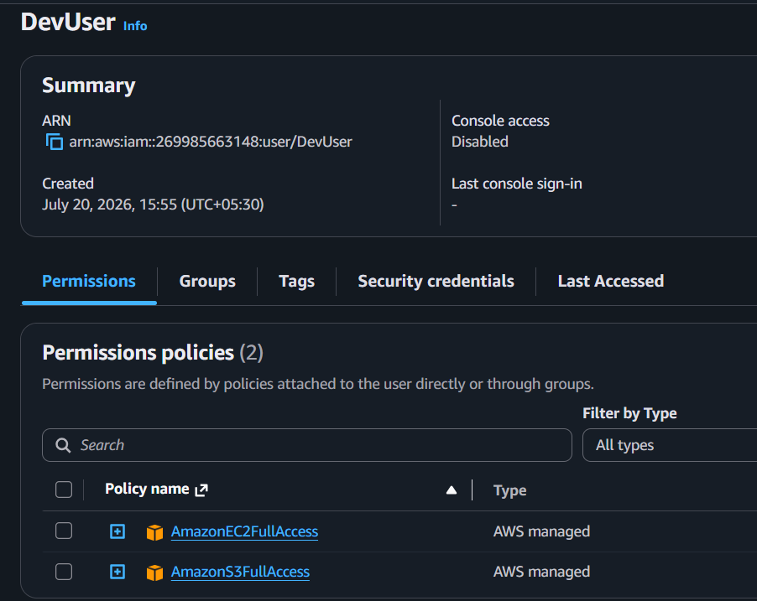

Validation 2
Login using DevUser credentials.
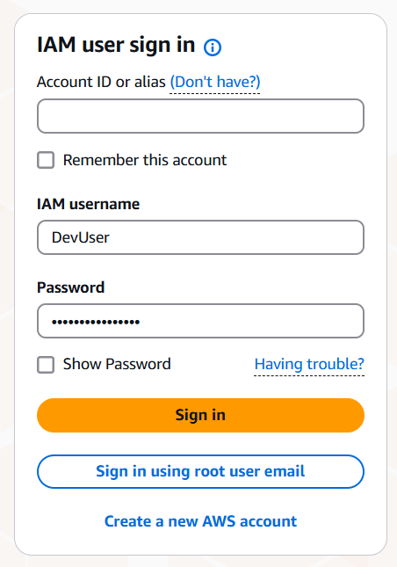
Try
EC2
→ Launch Instance
Should succeed.
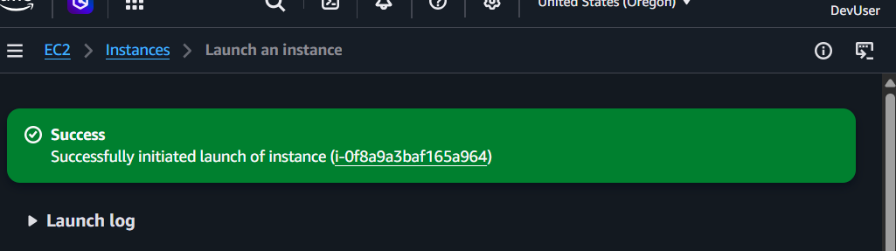

Validation 3
Go to
S3
→ Create Bucket
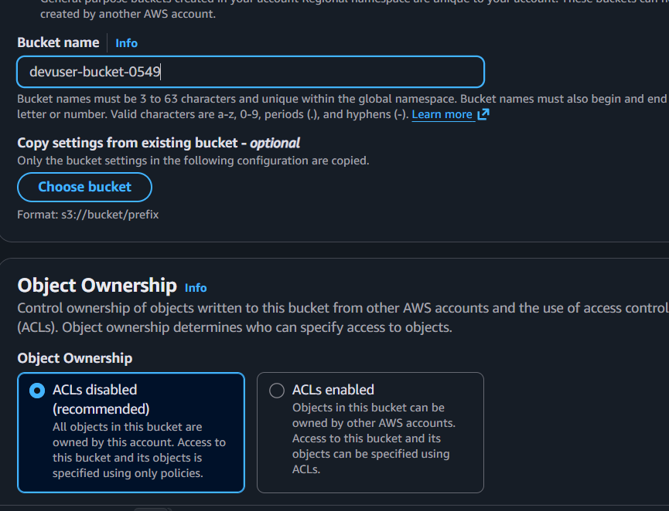
Should succeed.
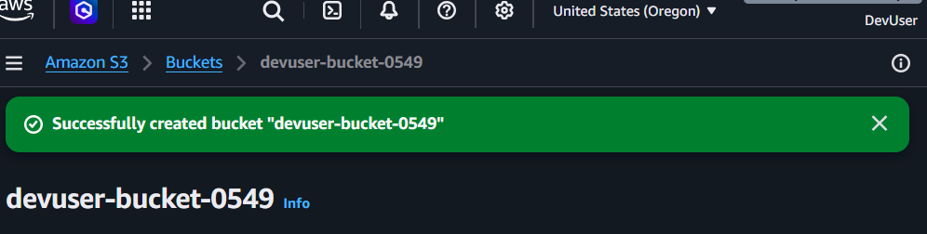

Validation 4
Try opening another service like
IAM
Expected
Access Denied
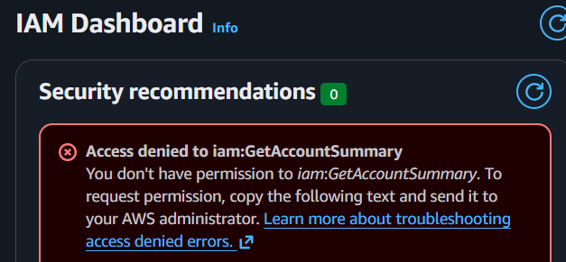
because IAM permissions were not granted.

Expected Outcome
User has
Full EC2 access
Full S3 access
No IAM access

Task 2: Create one IAM Group and assign EC2 Read Access

Objective
Create an IAM group that allows users to only view EC2 resources.

Prerequisites
- IAM permissions

Implementation

Step 1
IAM
→ User Groups
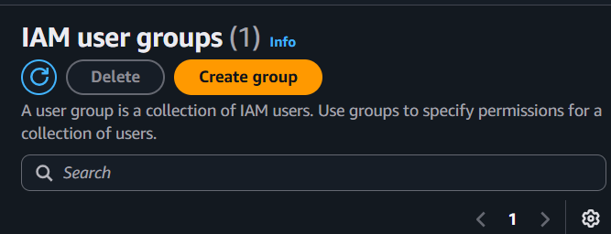
→ Create Group
Group Name
EC2-ReadOnly
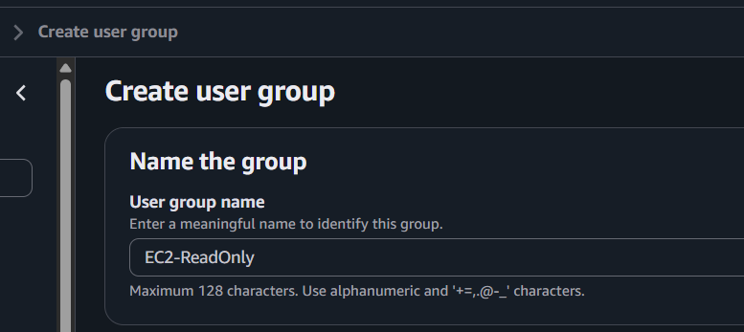

Step 2
Attach policy
AmazonEC2ReadOnlyAccess
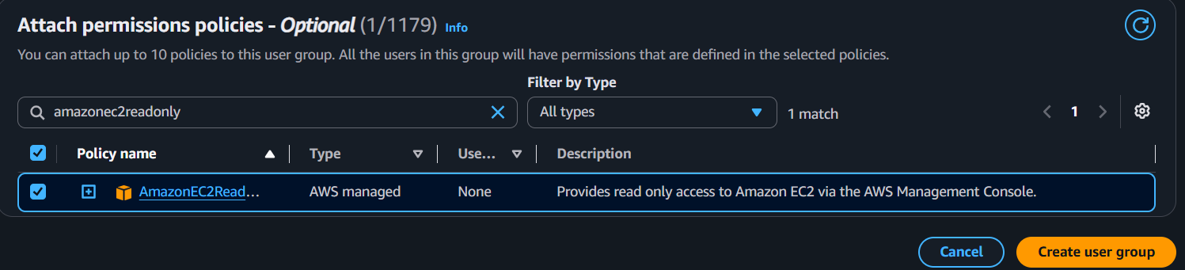
Click
Create Group
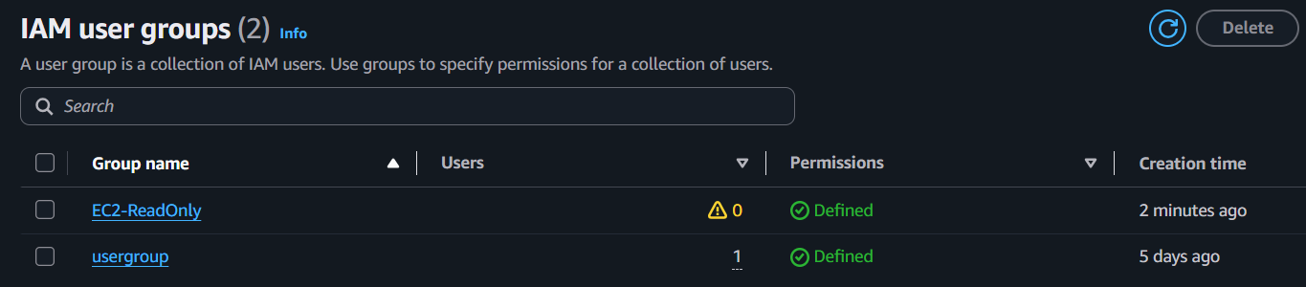

Validation
Open
IAM
→ User Groups
→ EC2-ReadOnly
Verify
AmazonEC2ReadOnlyAccess
is attached.
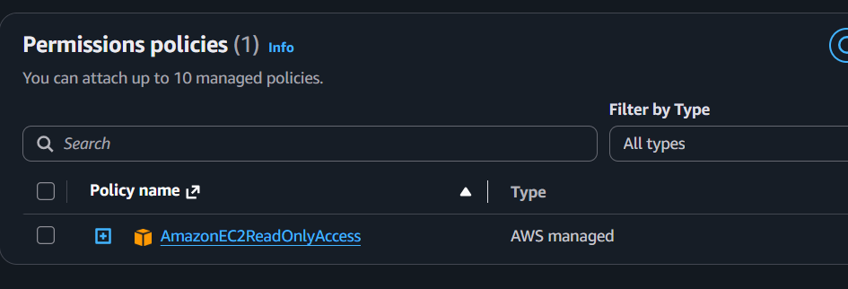

Create a temporary user and add to this group.
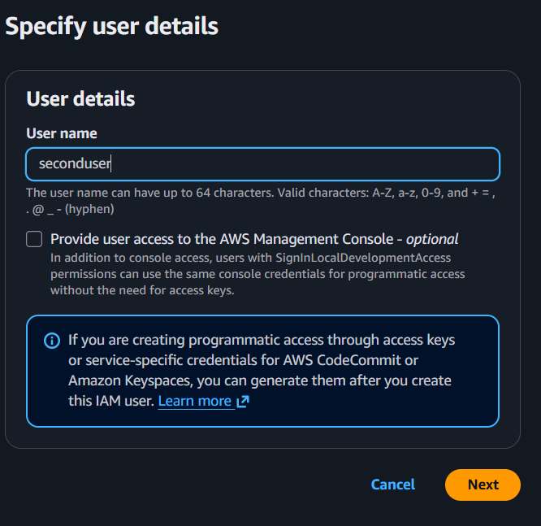
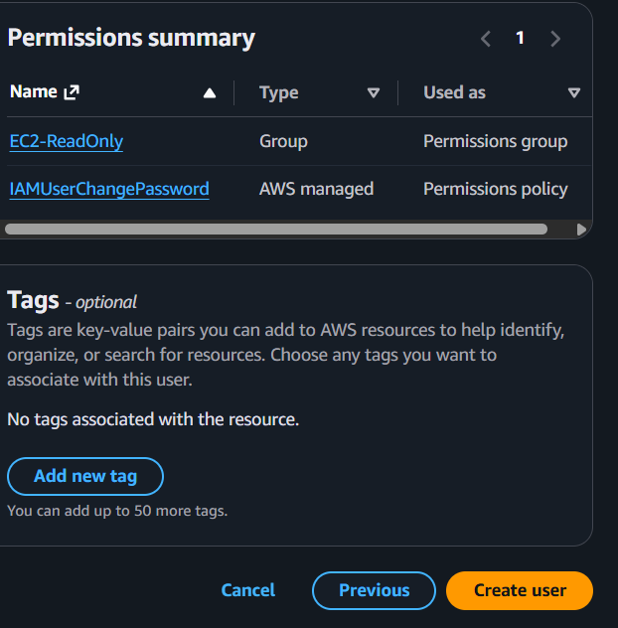
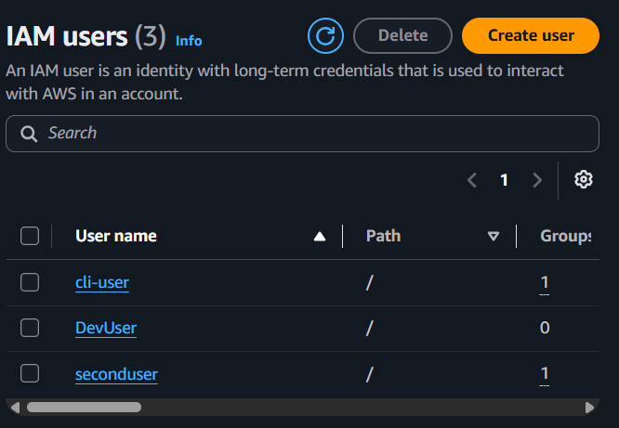
Login using that user.
Try
EC2
→ View Instances
Should work.
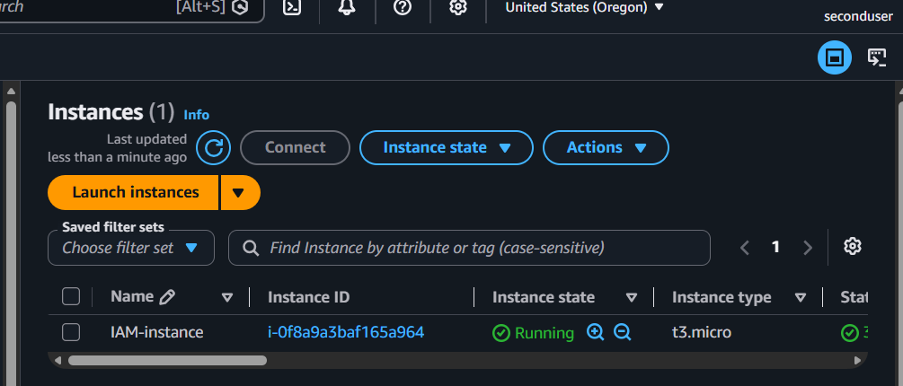

Try
Launch Instance
Terminate Instance
Stop Instance
Expected Access Denied
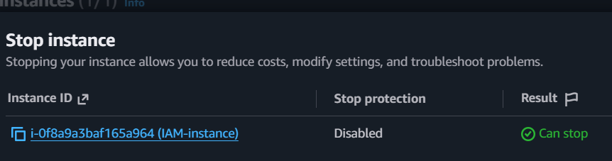

Expected Outcome
Users can View EC2 resources
Cannot Launch Terminate and Modify instances.

Task 3: Create User "Devops" and Add to Group

Objective
Provide EC2 ReadOnly permissions through group membership.

Prerequisites
Group “EC2-ReadOnly” already exists.

Implementation

Step 1
IAM
→ Users
→ Create User
Username
Devops
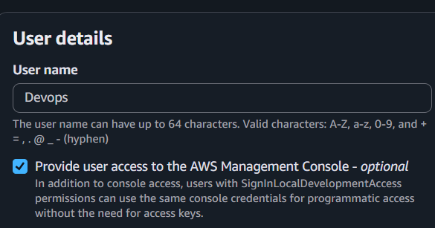

Step 2
Choose
Add user to group
Select
EC2-ReadOnly
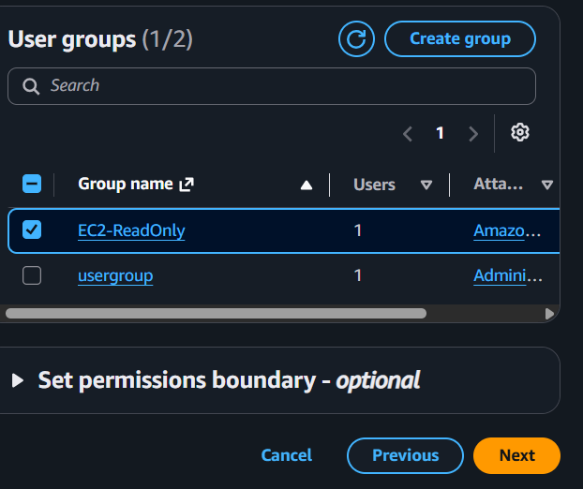
Create User.
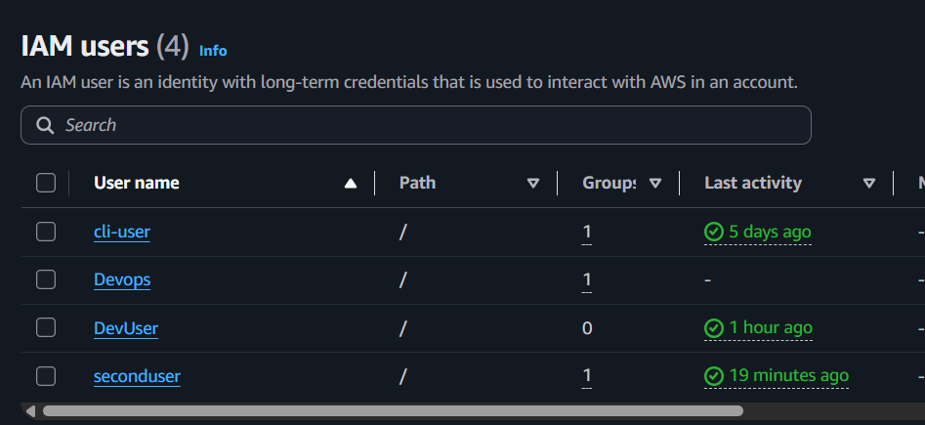

Validation
Open
IAM
→ Users
→ Devops
Verify
Groups

EC2-ReadOnly
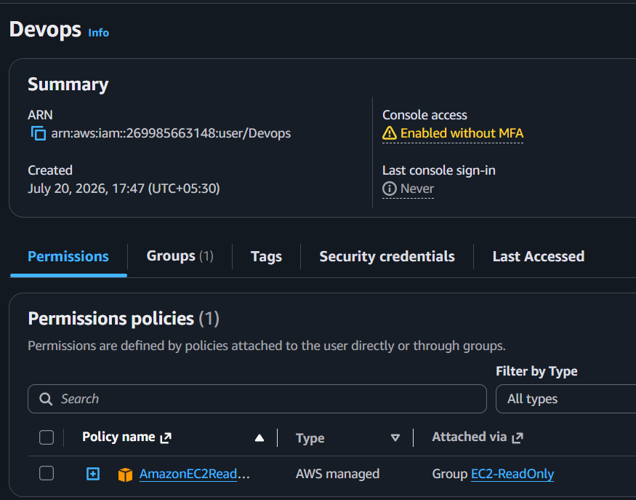

Login as
Devops
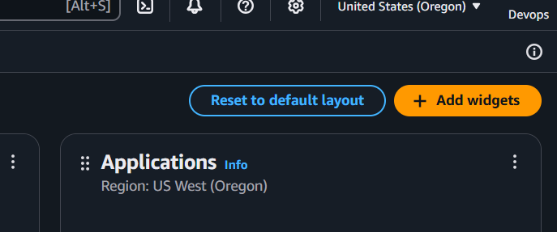
Go to
EC2
Verify
Instances visible
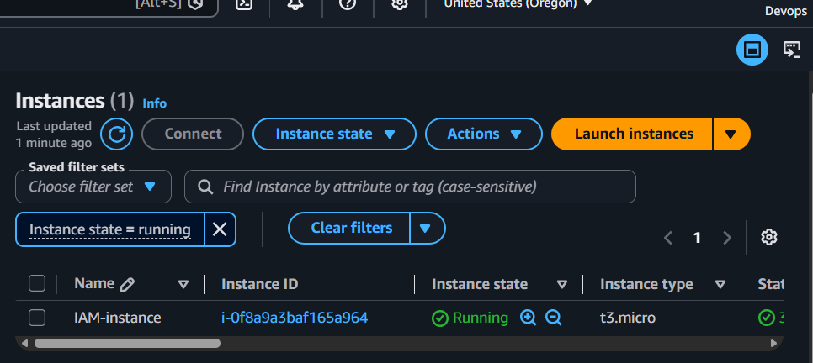
Try
Terminate Instance
Expected
Access Denied

Expected Outcome

Permissions are inherited from group.
Task 4: Write a Bash Script to Create an IAM User with VPC Full Access

Objective
Automate the creation of an IAM user and assign the AmazonVPCFullAccess managed policy using AWS CLI.

Prerequisites
Before running the script, ensure:
- AWS CLI is installed.
- AWS CLI is configured (aws configure).
- The logged-in user has IAM permissions:
  - iam:CreateUser
  - iam:AttachUserPolicy
  - iam:CreateLoginProfile (optional, if creating a console password)
- check before running the script as an Admin IAM user or the Root user.

Implementation

Step 1: Verify AWS CLI
aws --version

Step 2: Verify AWS Credentials
aws sts get-caller-identity
Output: 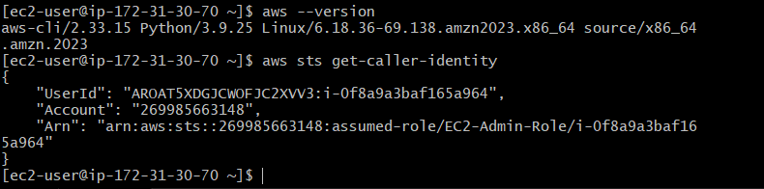
This confirms you're using an account with IAM permissions.

Step 3: Create the Script
Create a file:
vi create_iam_user.sh
write the following script
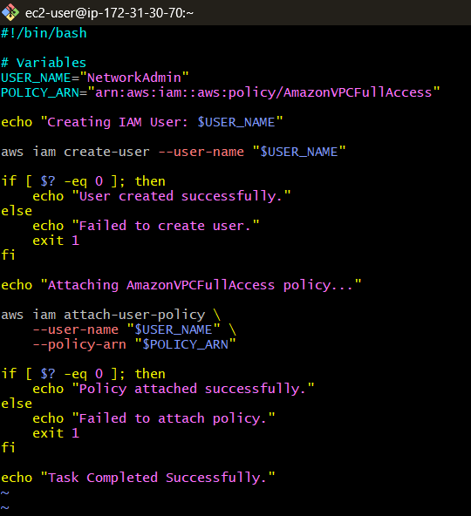
Save and exit.

Step 4: Give Execute Permission
chmod +x create_iam_user.sh

Step 5: Execute the Script
./create_iam_user.sh
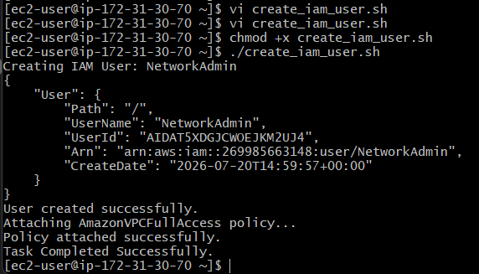.

Validation

Validation 1: Verify the User Exists
aws iam get-user --user-name NetworkAdmin
Output:
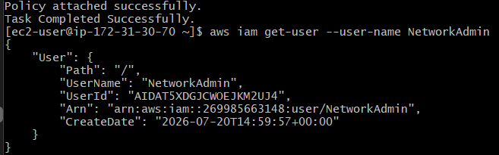

Validation 2: Verify the Attached Policy
aws iam list-attached-user-policies --user-name NetworkAdmin
Output:
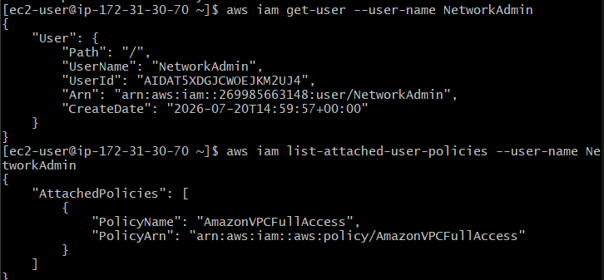

Validation 3: Verify in AWS Console
- Log in as the Admin account.
- Go to:
IAM → Users
- Open:
NetworkAdmin
- Select the Permissions tab.
Verify that:
AmazonVPCFullAccess
is attached.
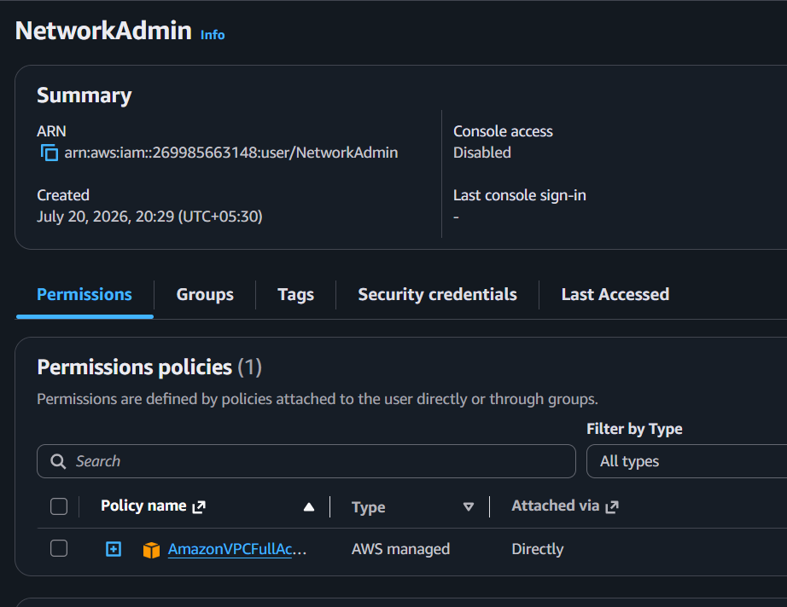

Expected Outcome
- ✅ IAM user NetworkAdmin is created.
- ✅ AmazonVPCFullAccess policy is attached.
- ✅ User appears under IAM → Users.
- ✅ Policy is visible under the Permissions tab.

Task 5: IAM Policy to Allow EC2 Access in Specific Regions Only

Objective
Restrict EC2 operations to specific AWS regions using an IAM policy.

Prerequisites
- IAM permissions
- Know the target region (e.g., us-east-1)

Implementation

Step 1
Go to
IAM
→ Policies
→ Create Policy
→ JSON
Paste:
{
"Version": "2012-10-17",
"Statement": [
{
"Sid": "AllowEC2InUSEast1Only",
"Effect": "Allow",
"Action": "ec2:*",
"Resource": "*",
"Condition": {
"StringEquals": {
"aws:RequestedRegion": "us-east-1"
}
}
}
]
}
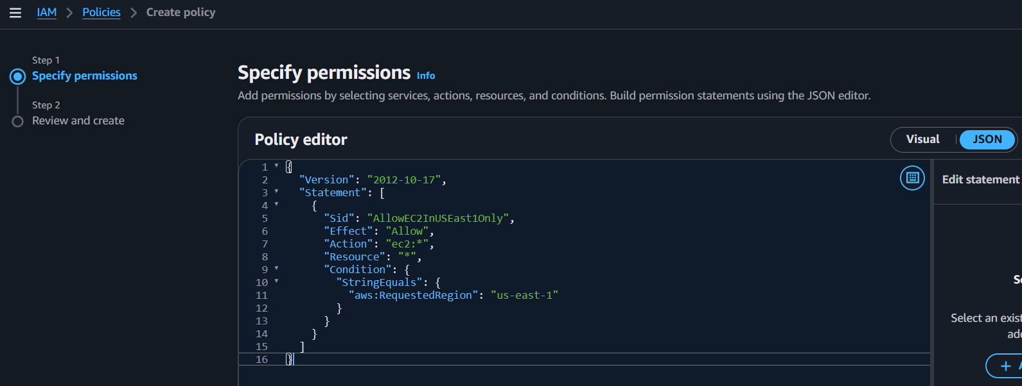

Step 2
Click
Next
Policy Name
EC2-USEast1-Only
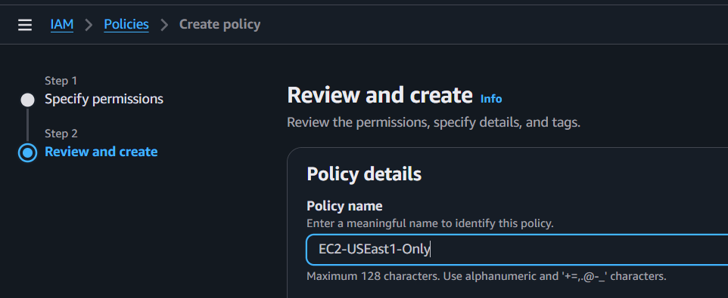
Create Policy.

Step 3
Attach policy
IAM
→ Users
→ DevUser
→ Add Permissions
Select
EC2-USEast1-Only
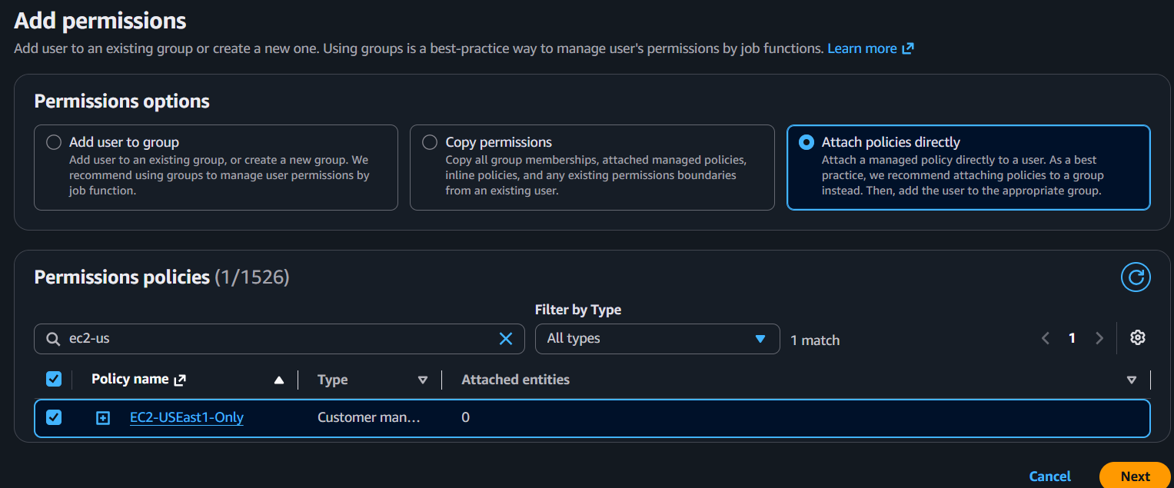
click next
Once you return to the DevUser page and see the policy listed
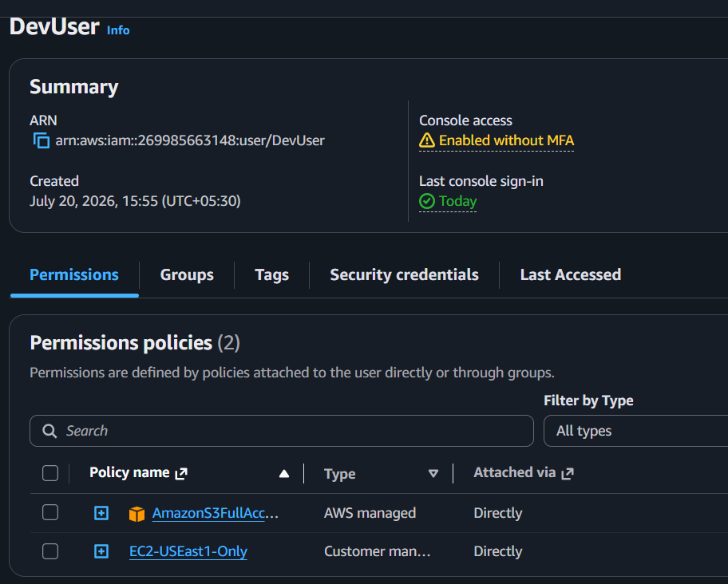

Validation
Login as
DevUser

Switch region
N. Virginia (us-east-1)
Launch EC2.
Expected
Success
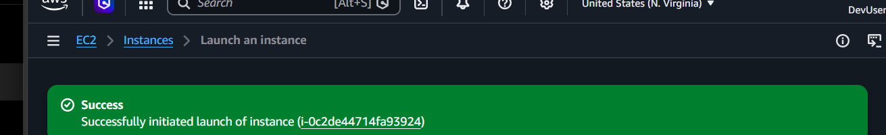

Switch region
Mumbai
Try launching EC2.
Expected
Access Denied
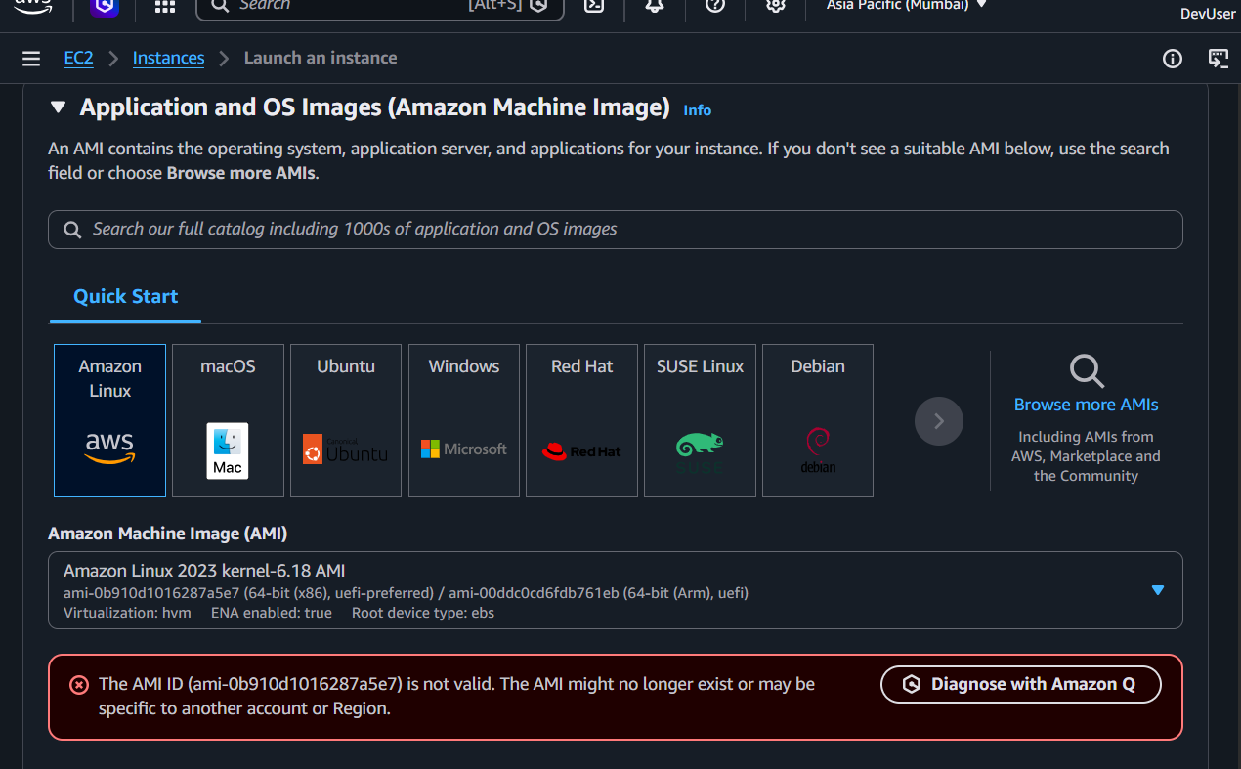

Use AWS CLI
aws ec2 describe-instances --region us-east-1
Expected
Success
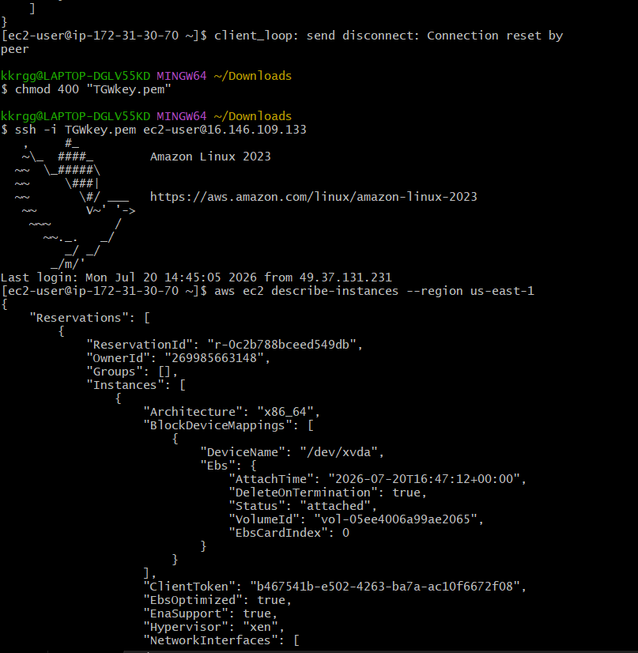

aws ec2 describe-instances --region ap-south-1
Expected
UnauthorizedOperation
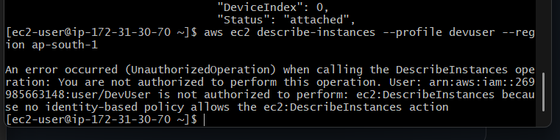

Expected Outcome
EC2 actions are permitted only in the specified region.

Task 6: Cross-Account S3 Access (Account A → Account B)

Objective
Allow a user in Account A to access an S3 bucket owned by Account B using a bucket policy.

Prerequisites
- Two AWS accounts:
  - Account A (contains IAM user)
  - Account B (contains S3 bucket)
- Exchange AWS Account IDs or IAM user ARN with your teammate.

Implementation

Step 1: Configure Account A
Login to Account A.
Navigate to:
IAM
→ Users
→ Devops
Create or attach the following IAM Policy.

IAM Policy
{
"Version": "2012-10-17",
"Statement": [
{
"Effect": "Allow",
"Action": "s3:ListBucket",
"Resource": "arn:aws:s3:::satishdevops-s3"
},
{
"Effect": "Allow",
"Action": [
"s3:GetObject",
"s3:PutObject",
"s3:DeleteObject"
],
"Resource": "arn:aws:s3:::satishdevops-s3/*"
}
]
}
Attach the policy to the Devops IAM user.
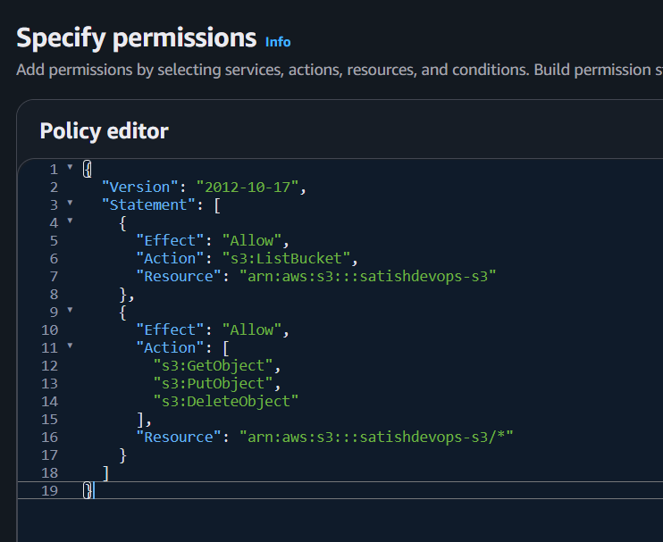

Step 2: Configure Account B
Login to Account B using DevOpsUser.
Navigate to:
Amazon S3
→ satishdevops-s3
→ Permissions
→ Bucket Policy
Paste the following Bucket Policy.

Bucket Policy
{
"Version": "2012-10-17",
"Statement": [
{
"Sid": "AllowListBucket",
"Effect": "Allow",
"Principal": {
"AWS": "arn:aws:iam::269985663148:user/Devops"
},
"Action": "s3:ListBucket",
"Resource": "arn:aws:s3:::satishdevops-s3"
},
{
"Sid": "AllowObjectAccess",
"Effect": "Allow",
"Principal": {
"AWS": "arn:aws:iam::269985663148:user/Devops"
},
"Action": [
"s3:GetObject",
"s3:PutObject",
"s3:DeleteObject"
],
"Resource": "arn:aws:s3:::satishdevops-s3/*"
}
]
}
Save the Bucket Policy.

Step 3: Configure AWS CLI
Configure AWS CLI using the Devops IAM user's Access Key and Secret Key.
aws configure
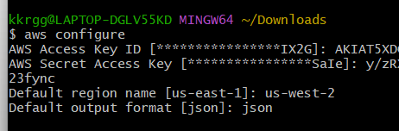
Verify the configured identity.
aws sts get-caller-identity
Expected Output
Account : 269985663148
User : Devops
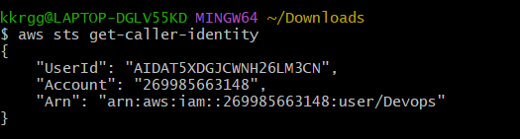

Step 4: Validation

List Bucket
aws s3 ls s3://satishdevops-s3
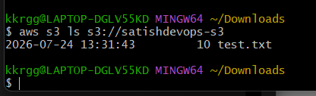

Expected Outcome
The IAM user in Account A can access only the S3 bucket that Account B explicitly shared, demonstrating secure cross-account access without sharing account credentials.

